#1 Code Snippet

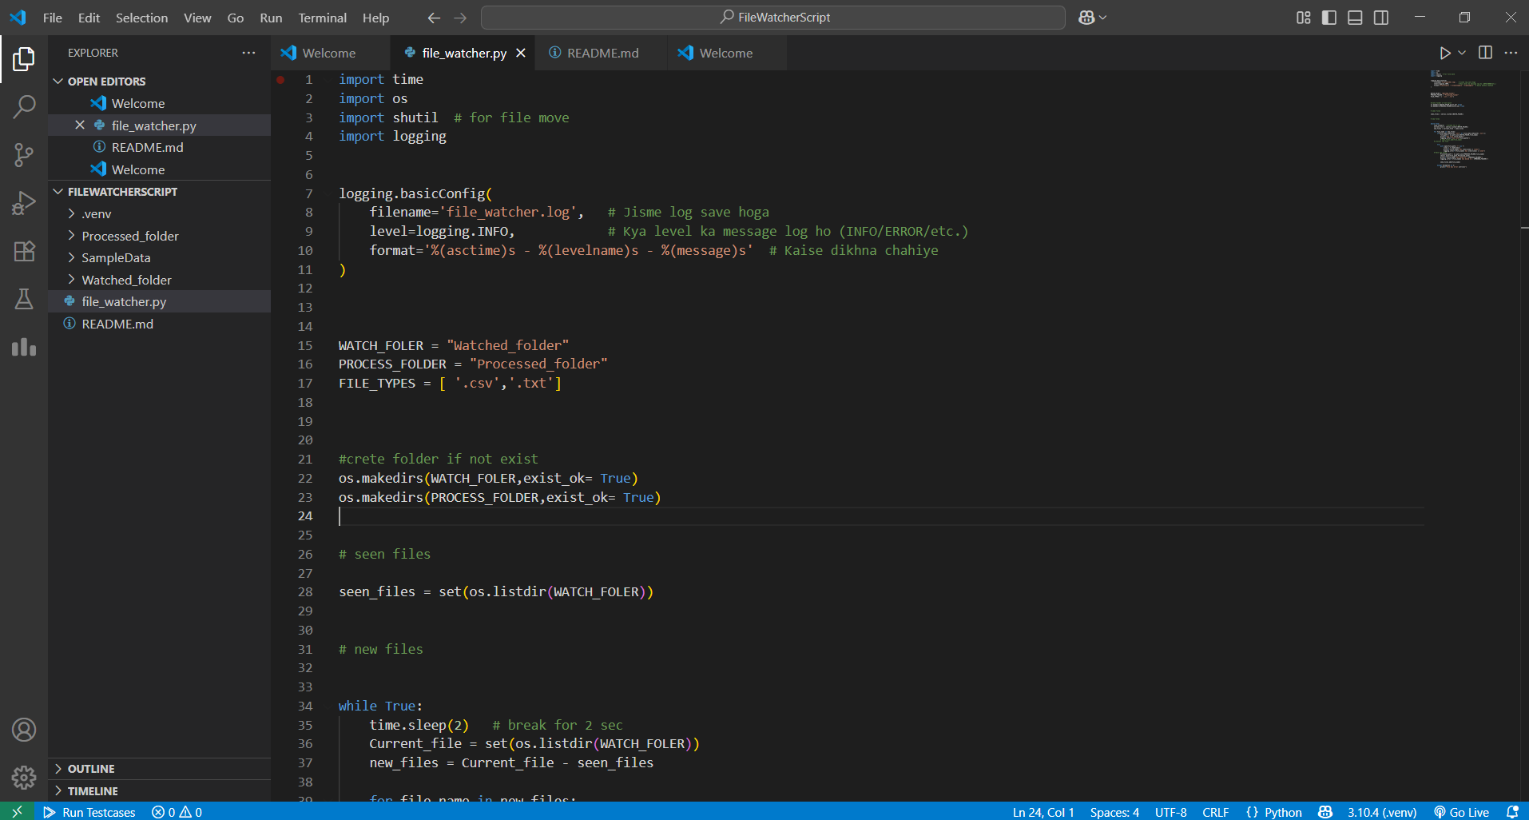

#2 Watched Folder

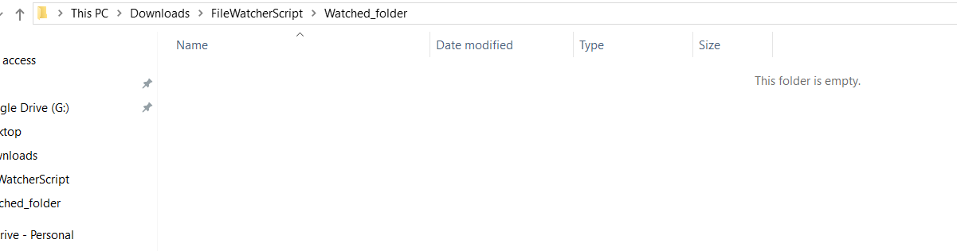

#3 Sample file Placed in Wathced Folder

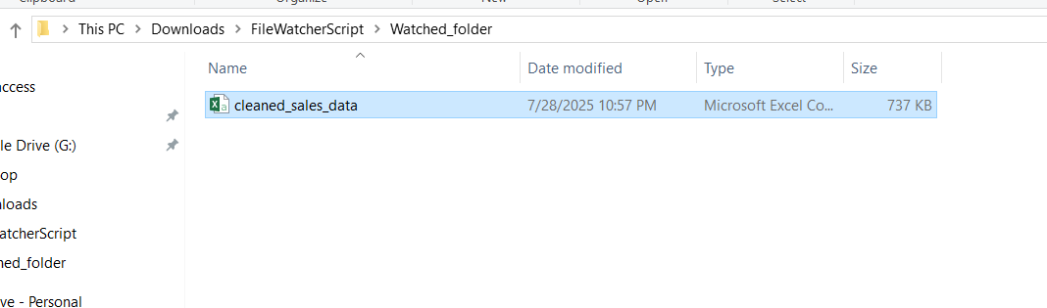

#4 File Processed and log file create.

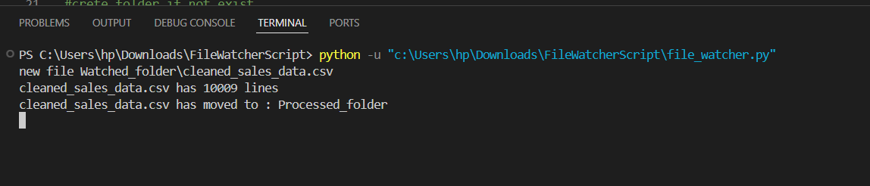

#5 File moved to Processed folder

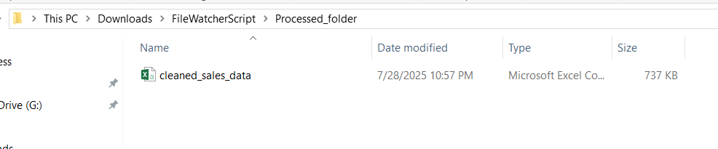

#6 Log file Output.

